**MODULE 4 – Introduction to Policy For EV**

**4.5 Summary**

Practice Problems

The following image shows the pollution source contributions to the total PM 2.5 emissions.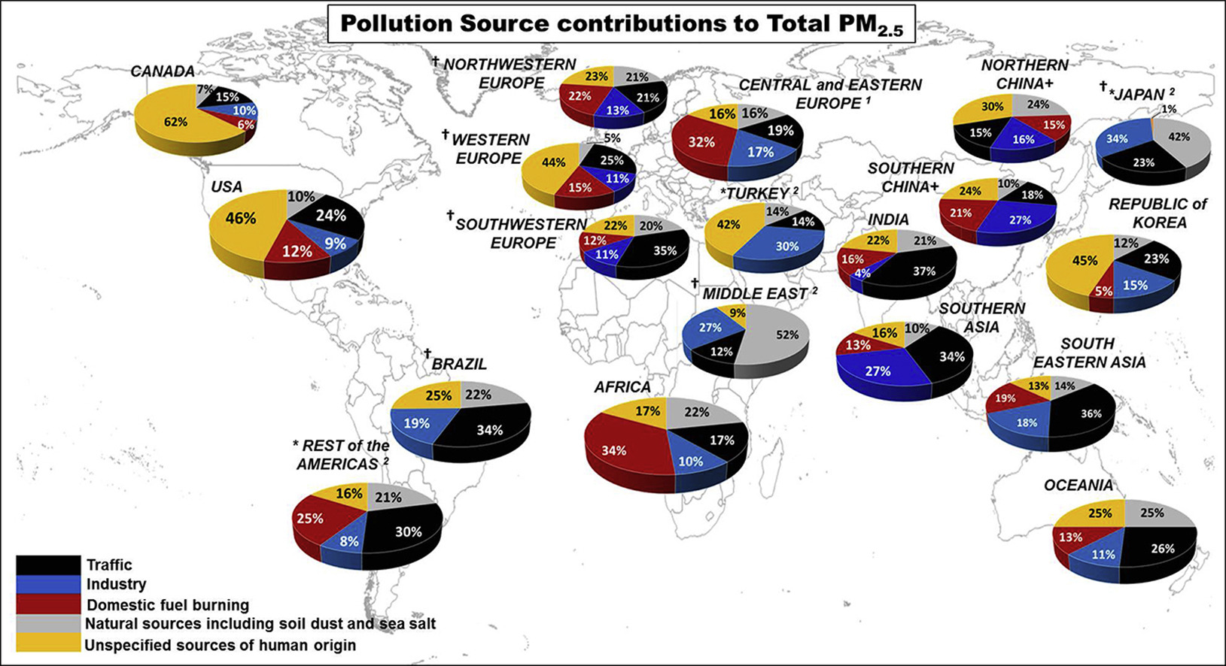

### Question 1 Based on the figure above, for which country/countries is traffic the most important contributor to ambient PM?

1. India
2. Canada
3. USA
4. Brazil
5. Oceania

Ans. A, D, E

### Question 2 Based on the figure above, which countries are not active with domestic fuel burning?

1. Turkey
2. Brazil
3. Canada
4. USA

Ans. A, B

### Question 3 Please read the statements and answer the question below.

A) Domestic fuel burning includes wood, coal and gas fuel for cooking or heating. A typical case of household air pollution coal burning for domestic heating is found in Central Europe where wood and coal are used for domestic heating.

B) Natural sources including soil dust and sea salt. Dust is characterized by elements abundant in the earth's crust rocks and the soil. These components of PM are associated with the re-suspension from fields or bare soils by local winds.

Based on the contributions to cities' ambient particulate matter (PM), indicate if the following if the following statements are correct.

1. Answer A) is correct.
2. Answer B) is correct.
3. Both answers are correct.
4. None of the answers is correct.

Ans. C

### Question 4 Here you will find a statement and reasoning. State true, if the reasons support the statement, and false, if the reasons don’t support the statement.

Statement: Congestion can be avoided better by grid capacity expansion than by control battery recharging.

Reasoning: Control battery recharging is a far cheaper solution than grid capacity expansion.

1. True
2. False

Ans. B

### Question 5 Information: For an average electric car, driving 30 km on average per day, the annual electricity demand is of the same order of magnitude as the annual electricity demand of an average household in the Netherlands, which is around 3500 kWh.

Consider the two statements given below and choose the correct option:

**A.** The information implies that residential electricity use, for an average household with just one car, will be doubled if the conventional car is replaced with an electric car that is mostly recharged at home.

**B.** A household with two average driving cars will have the same electricity demand as a household with just one car but driving 100 km a day.

Select the correct option from the options below:

1. Both statements are true
2. Statement A is true and statement B is false.
3. Statement A is false and statement B is true
4. Both statements are false

Ans. B